**DFRobot EC Sensor Calibration (Updated 10/18/2021)**

Jonah Gonzales

**Sensor Description:**

This sensor uses two electrodes to run a small current through the liquid being tested to measure conductance, the reciprocal of resistance. This measurement is an indicator of how many ions are present in the water, as higher conductivity means more ions present. For the purposes of hydroponics, nutrients are presented as salts, which break down into ions, so the conductivity of the water can be used as a good measure of nutrient levels within the water, which can be adjusted as needed to promote plant growth. (OK State)

**Schematic, Calibration Fluids, Configured Probe w/ Arduino:**

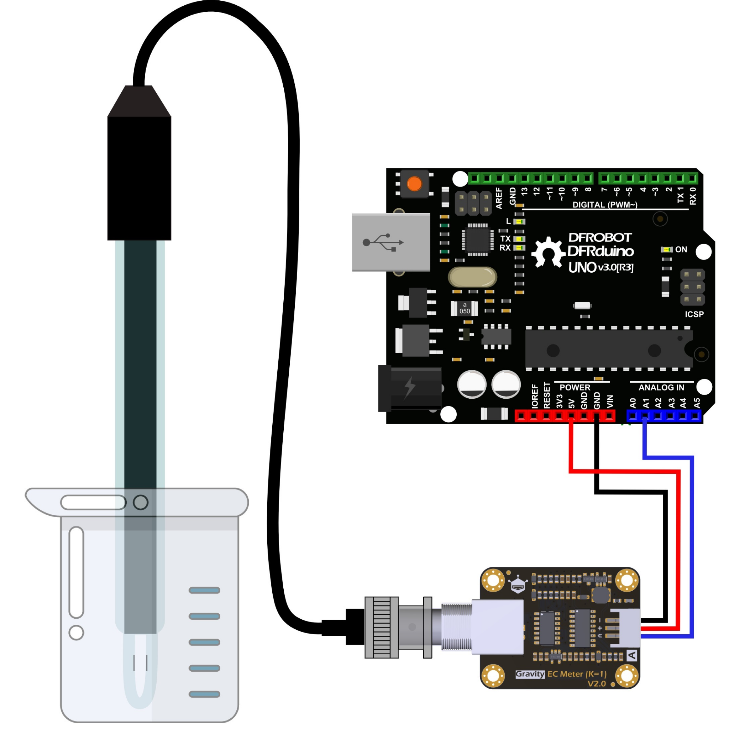

**Black - Ground**

**Red - 5V**

**Blue - Analog Port 1**

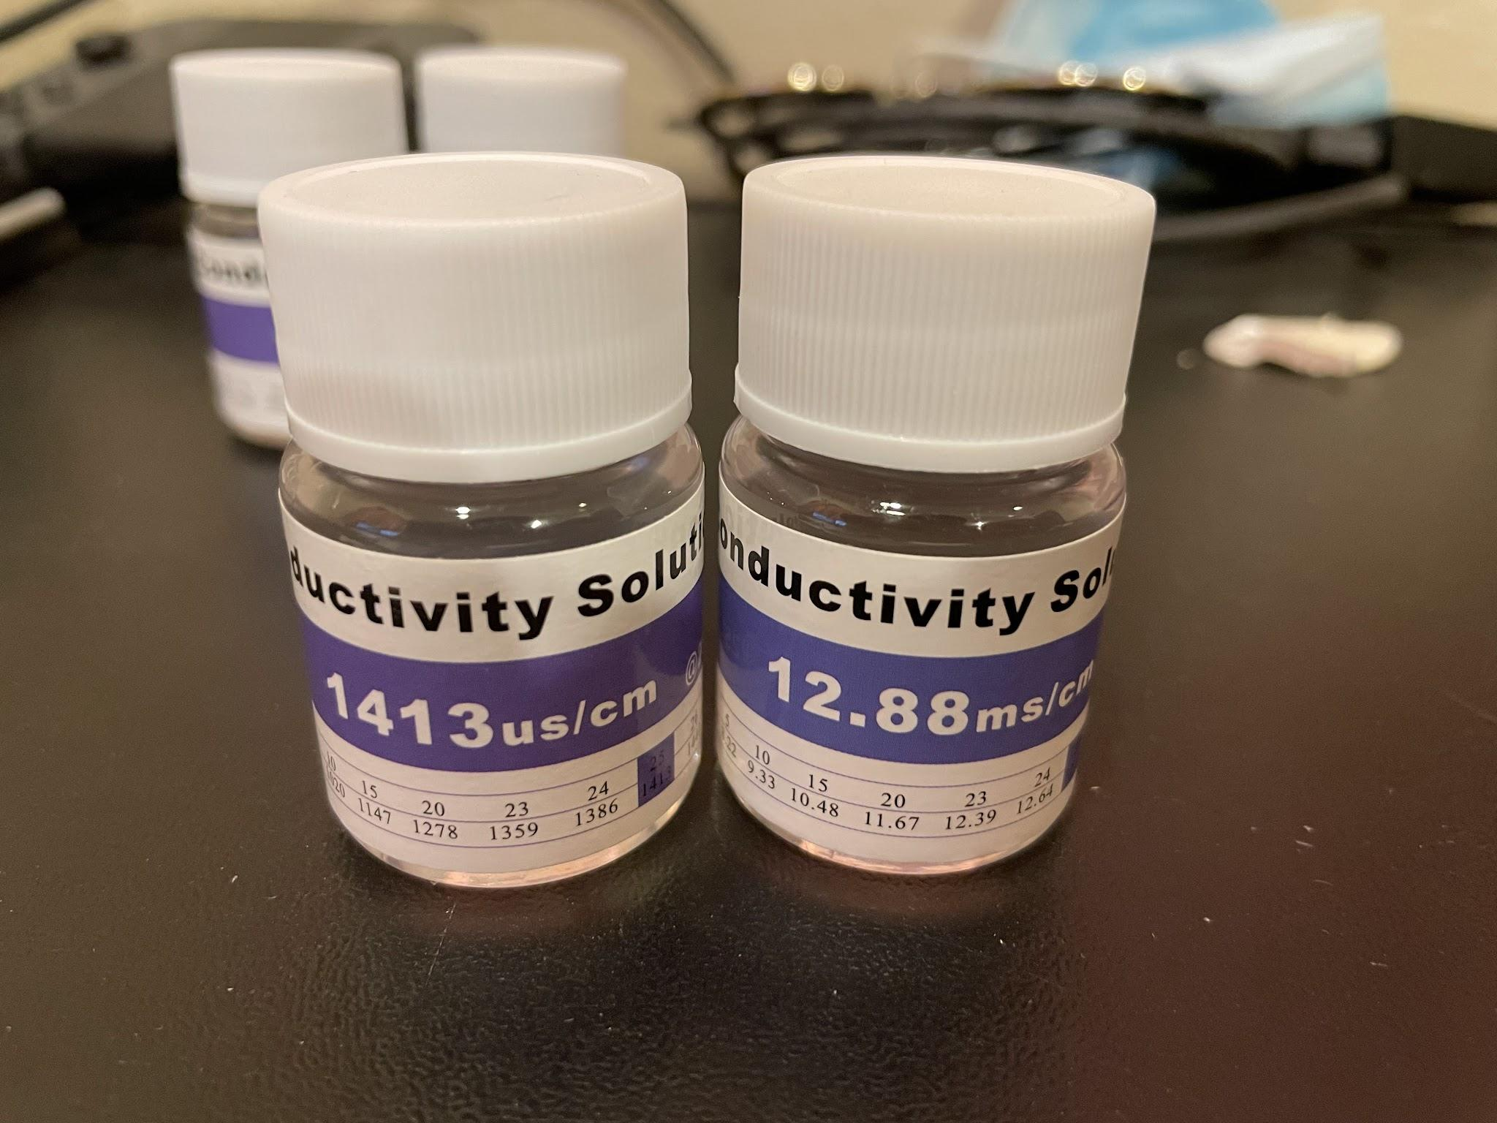

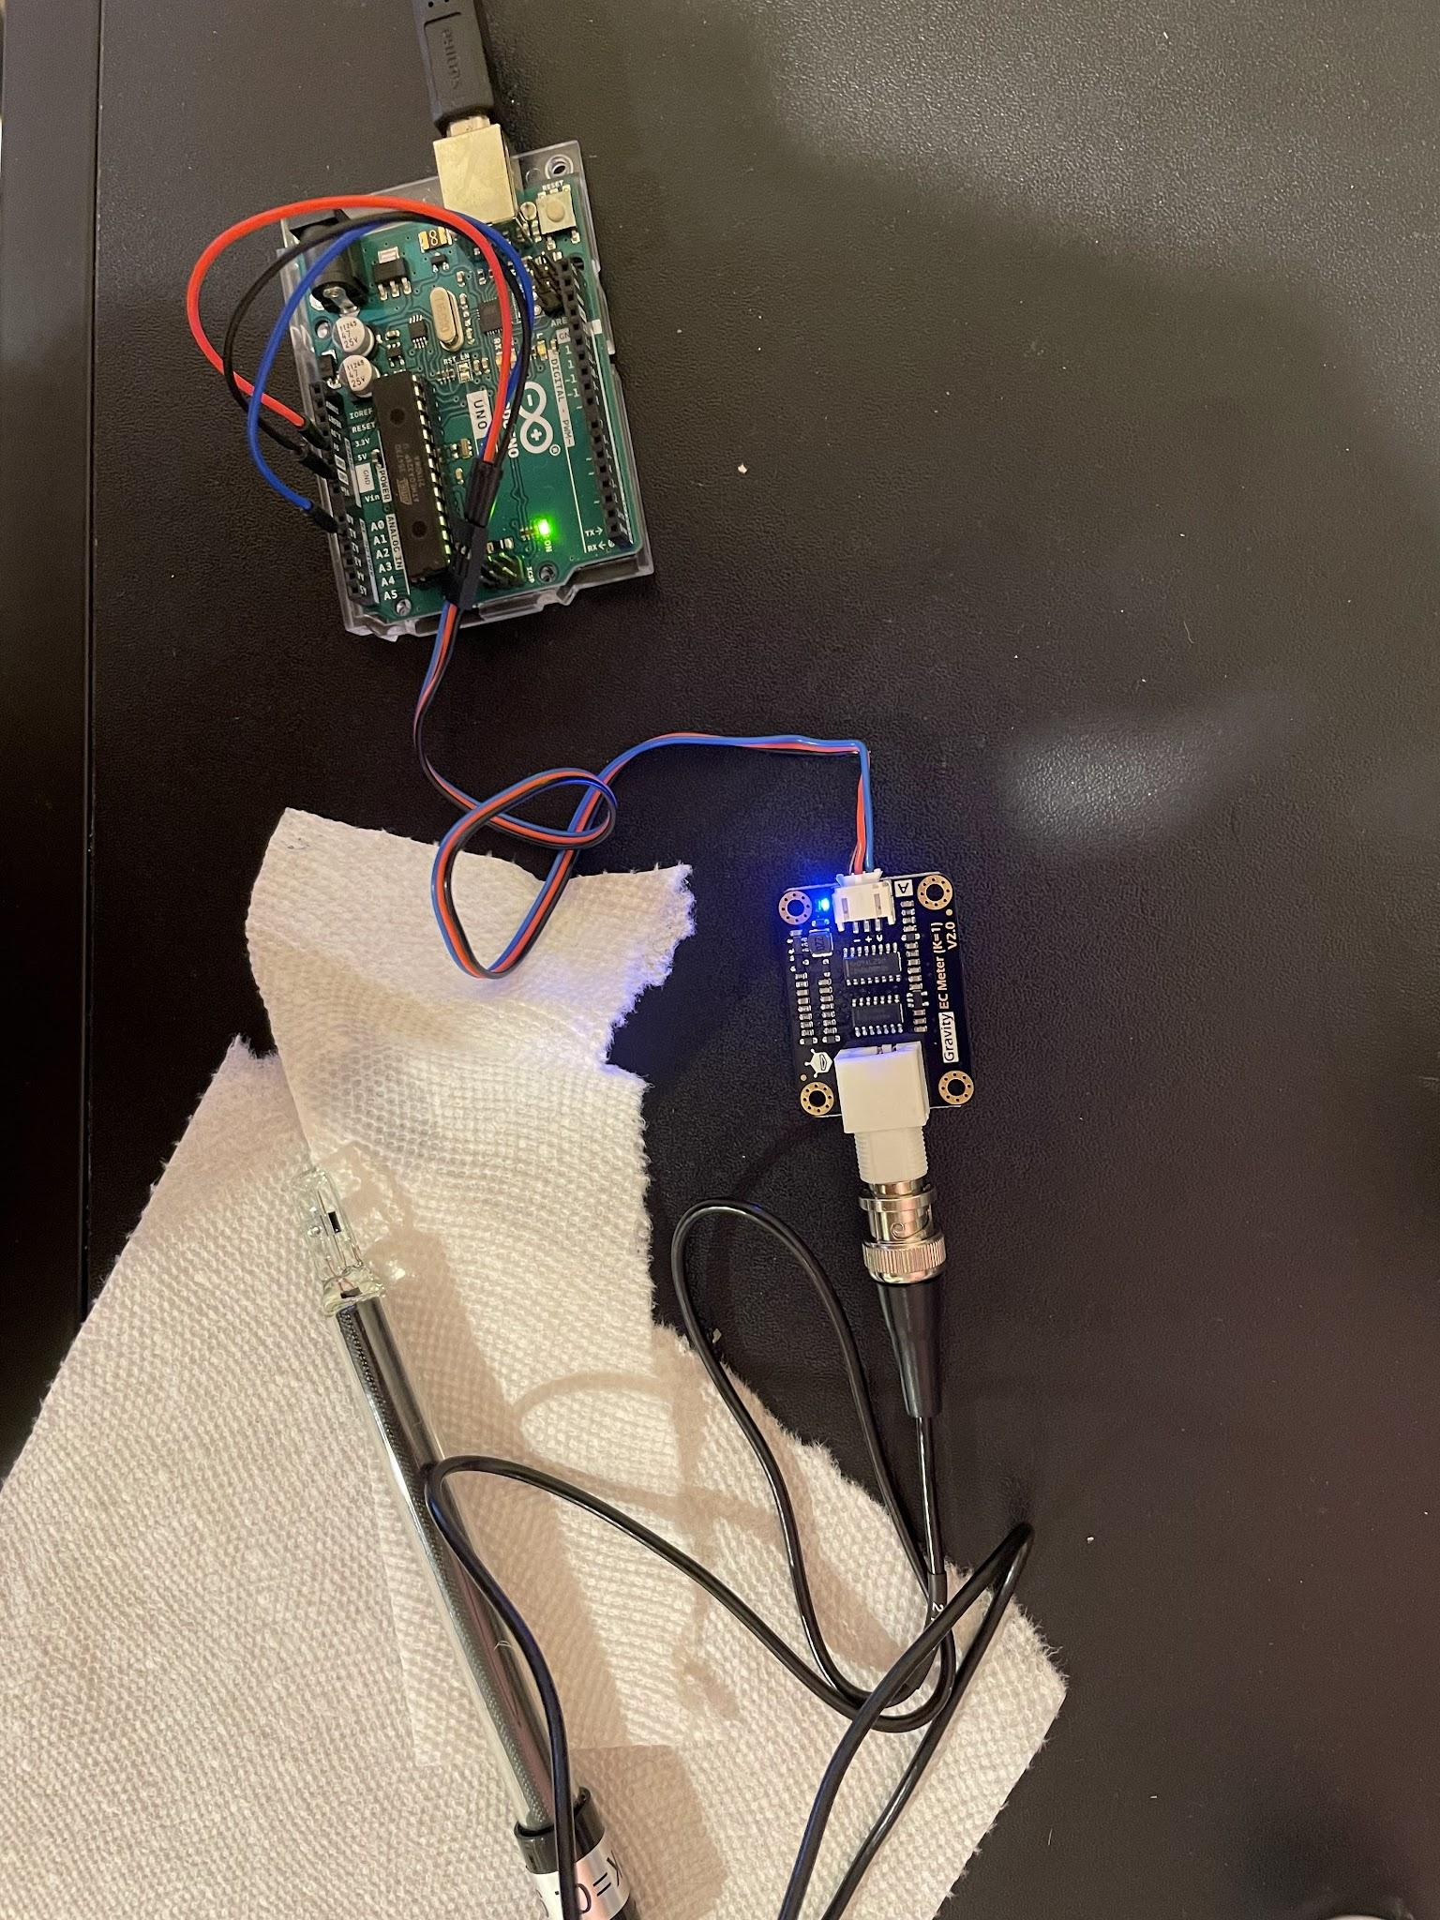

**Calibration Code (Provided by DFRobot):**

#include "DFRobot_EC.h"

#include <EEPROM.h>

#define EC_PIN A1

float voltage,ecValue,temperature = 25;

DFRobot_EC ec;

void setup() {

Serial.begin(115200);

ec.begin();

}

void loop()

{

static unsigned long timepoint = millis();

if(millis()-timepoint>1000U) //time interval: 1s

{

timepoint = millis();

voltage = analogRead(EC_PIN)/1024.0*5000; // read the voltage

temperature = 25; //Temporary value until temp sensor added

//temperature = readTemperature(); // read your temperature sensor to execute temperature compensation

ecValue = ec.readEC(voltage,temperature); // convert voltage to EC with temperature compensation

Serial.print("temperature:");

Serial.print(temperature,1);

Serial.print("^C EC:");

Serial.print(ecValue,2);

Serial.println("ms/cm");

}

ec.calibration(voltage,temperature); // calibration process by Serail CMD

}

**Pre Calibration(1413 us/cm)**

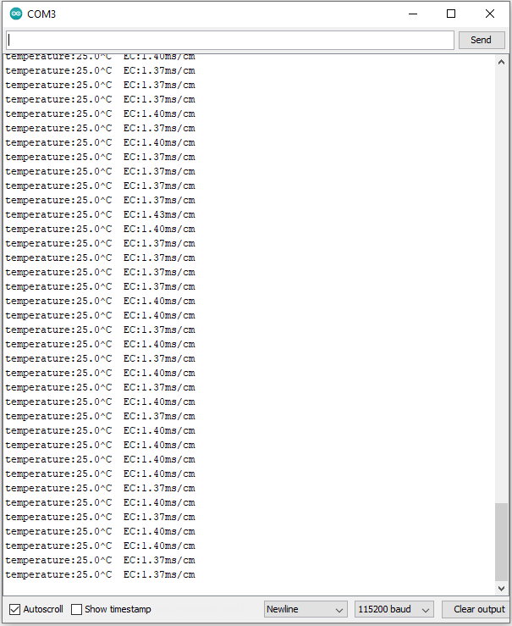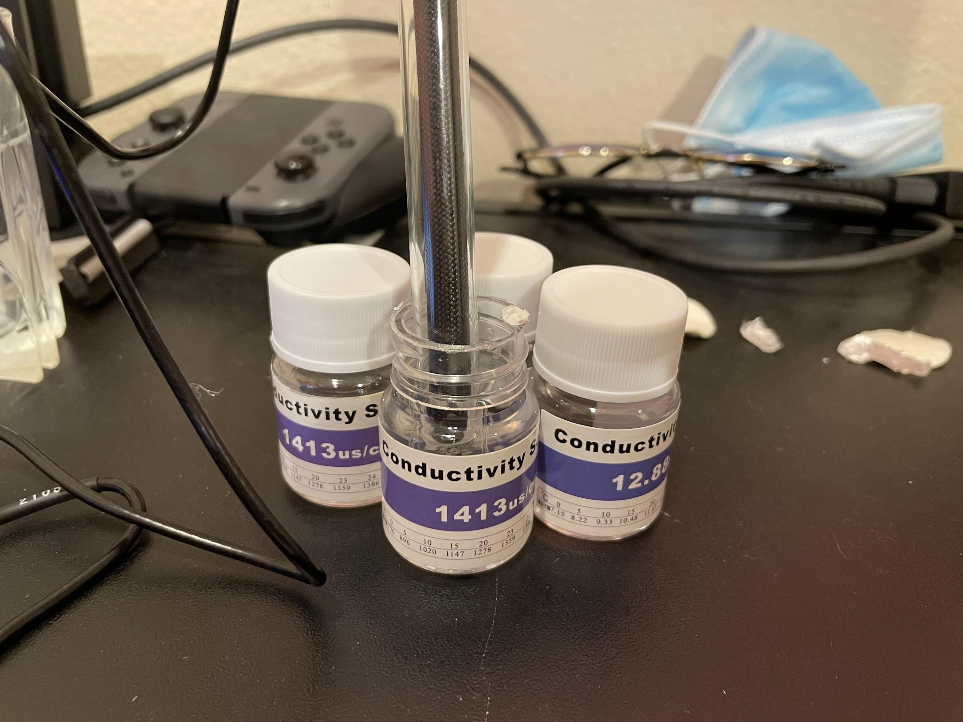

**Post Calibration (1413 us/cm)**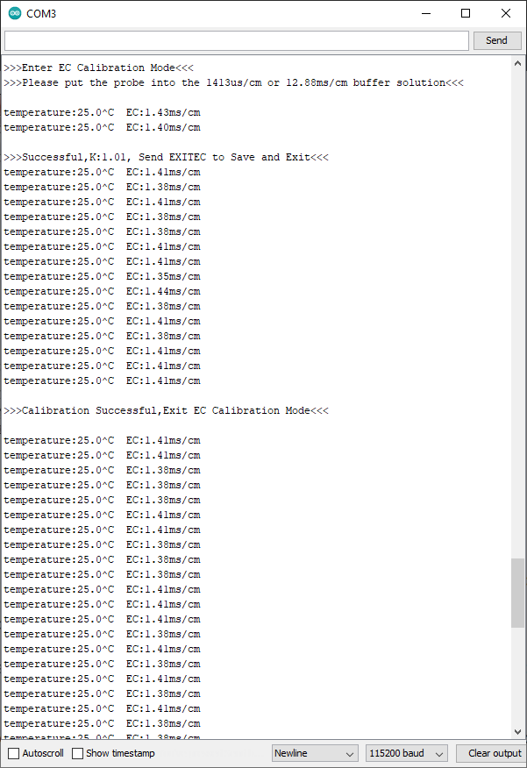

**Pre Calibration (12.88 ms/cm)**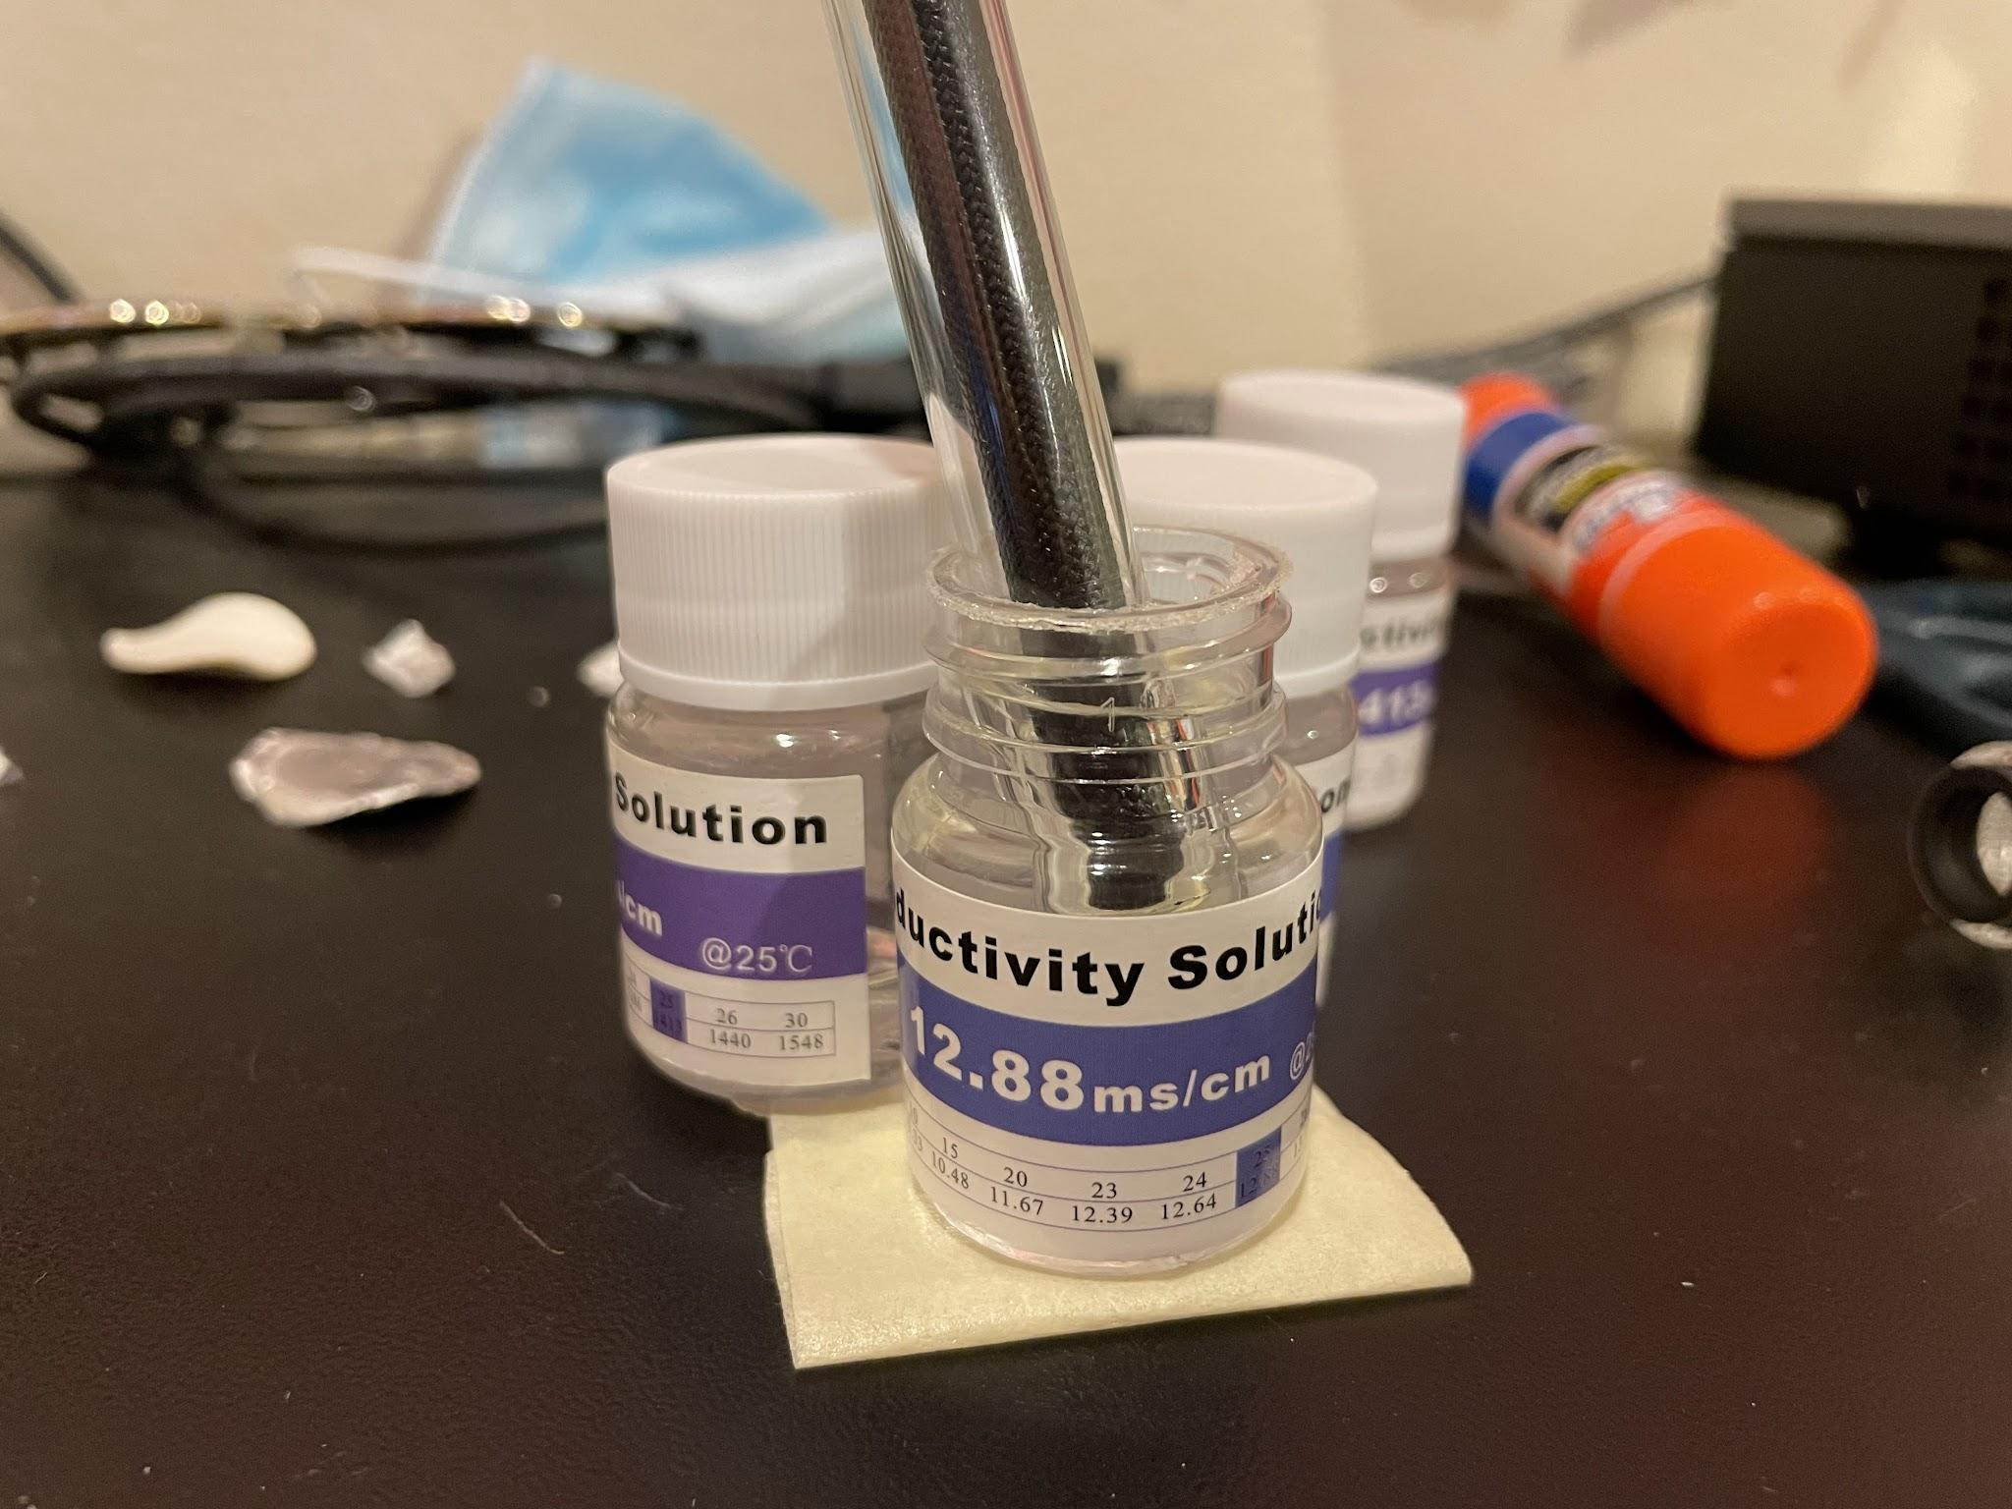

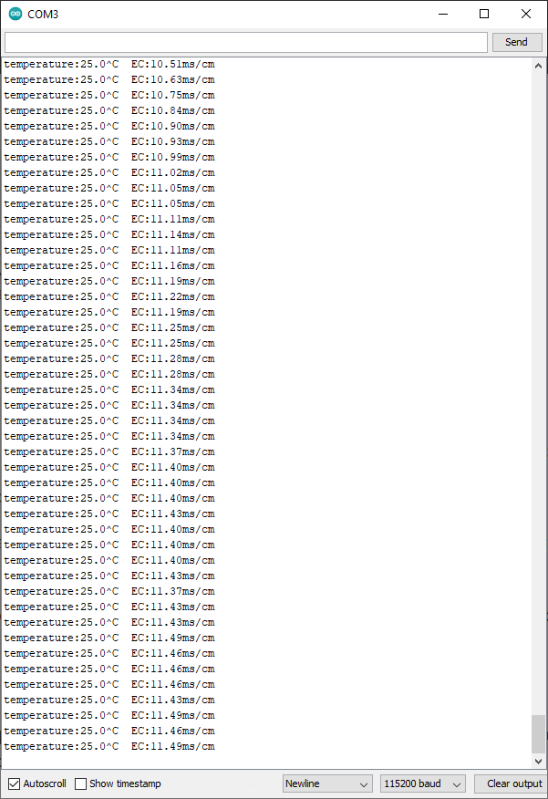

**Post EC (12.88 ms/cm)**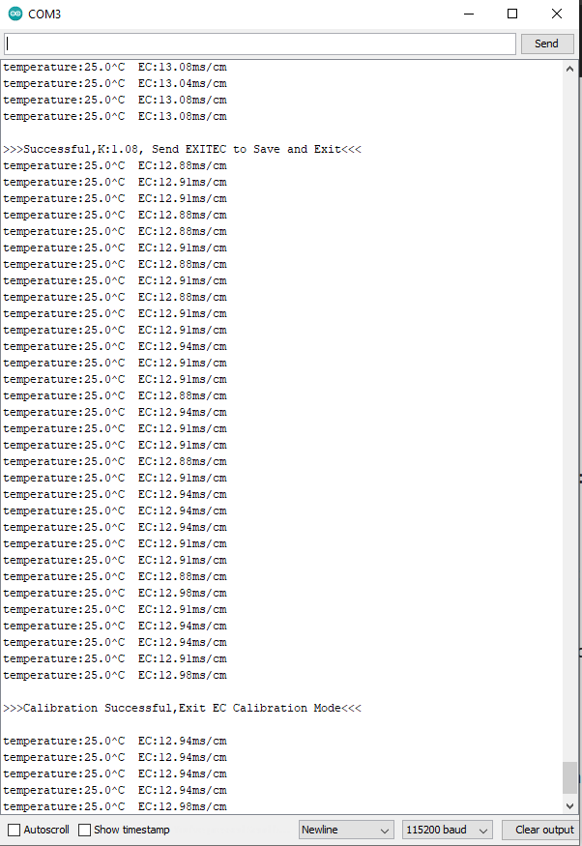

**Ending Notes:**

Once calibrated, the values relatively stabilized with a 1-2% error margin. However, these measurements do not reflect the change in conductivity due to the temperature of the solutions, which we will be able to monitor and account for with the temperature probe. For these purposes, I used 25 C as the baseline, which definitely affected the calculated values. The DFRobot Libraries already have temperature compensation functions which I can use once the temperature probes come in and I start testing.

**References:**

**Calibration Instructions from DFRobot Website:** <https://wiki.dfrobot.com/Gravity__Analog_Electrical_Conductivity_Sensor___Meter_V2__K%3D1__SKU_DFR0300>

**Info on Conductivity & Hydroponics:**

<https://extension.okstate.edu/fact-sheets/electrical-conductivity-and-ph-guide-for-hydroponics.html>